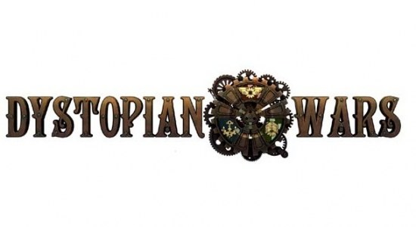
Call to Arms 2017

Organiser Details
Nathan Wright – nibletindustries@gmail.com
When and Where
5th and 6th August 2017, St Patrick’s College Hall, 581 Evans Bay Parade, Kilburnie, Wellington.
Registration and Payment
Cost for the two days of awesome is $45 by 24 July 2017. After that the registration costs go up to $60. To get the payment details you need to register through the website using the below link:
https://warlords.org.nz/call-to-arms/
Rules
Dystopian Wars Rulebook 2.5 henceforth known as ‘The Book of Roolz’.
Fleet Building
- No Invaders. Please, just don’t.
- Your fleet will be Naval core, with a 1000pt limit.
- Allied nations may be taken as part of your non-core force.
- Fortifications are allowed, as are strategic assets (repair boats etc) and these count as non-core.
- TAC cards will be used, consisting of a 4-card deck which will be included as part of your fleet list.
- Advanced/Reserve forces are allowed, up to 400pts.
- Dreadnaught class models are not allowed.
- A maximum of 20 additional wings of tiny fliers will be allowed, in addition to the 10 local air support.
- Local air support type may be declared when they are deployed, although squadron sizes must be fixed throughout.
- A limit of 400 points of non-core models can be included.
- Your army must consist of Small class: 150-400 points, Medium class: 250-600 points, Large/Massive class: 250- 600 points.
Please send me your lists by Friday 28th July for checking. My e-mail is: nibletindustries@gmail.com
Format
Missions will be chosen by the players after deployment but before the first turn. This means you (and your opponent) will be allowed to pick from the following.
- Score 500pts and destroy all small class models
- Score 500pts and destroy all medium class models
- Score 500pts and destroy all large/massive class models
Destroying 700pts will always remain as a victory condition, regardless of the other option you choose.
Games will be played on a 6'x4' table, terrain will be pre-determined.
Models and Painting
For the most part models must be the Spartan model with a minimum of three base colours on it. In theory I’m ok with proxies but it has to look like what it’s supposed to represent. If you are wanting to use a proxy, then you’ll need my permission. e-mail me with a picture or link to a picture of the model and what you are wanting it to represent and I’ll let you know if it’s all good or not.
What to Bring
- A copy of ‘The Book of Roolz’.
- 2 copies of your army list; one for you, one for your opponent.
- Tape measure.
- Models.
- Dice. Lots of dice.
- Damage markers/critical effect tokens etc. etc.
- A Pen. Preferably pink but other colours are welcome.
- Some form of stats for all your models so your opponent can see what they do. Unit Stat Cards are the most common version of this but if you have something else that’s fine, as long as when your opponent asks to see what a unit does you can clearly show them.
Schedule
Saturday
8:30 – Briefing
9:00 – Game 1
11:30 – Game 1 ends – Lunch
12:00 – Game 2
14:30 – Game 2 ends
14:45 – Game 3
17:15 – Game 3 ends
Sunday
9:00 – Game 4
11:30 – Game 4 ends – Lunch and Judging Painting
12:30 – Game 5
15:00 – Game 5 ends and pack-up
15:30 – Prizegiving
Draw and Game Points
The Draw for the first 2 games I will pair up players from different clubs with each other, giving people a chance to play players they haven't before. The next 2 games will be pseudo random pairings, avoiding playing the same player twice where possible. The final will pair off players who are close in score. Games will be scored as follows
Crushing Defeat 0 TP
Narrow Defeat 1 TP
Draw 2 TP
Narrow Victory 3 TP
Crushing Victory 4 TP
Tie-breakers will be determined by highest VP scored, followed by lowest VP given away.
Prizes
There will be a prize for Best General, Best Painted and Best Sports. I’ll try to get another Spartan Tournament kit if they do them. We will also have some spot prizes to dish out.
Other Stuff
- The ‘don’t be a dick’ rule. This is likely to be a smaller event with some greener players. There’s nothing wrong with playing to win, what with it being a tournament and all, just remember not to be a savage about it. If I have to explain to anyone how to behave like an adult, they will be taken out to the back room and spanked.
- After games beersies on Saturday Night. I’m happy to try and organise somewhere for us all to catch up on Saturday night for something to eat and some post tournament banter. Please let me know if you’re interested by e-mail so I have an idea of numbers for booking. That e-mail again: nibletindustries@gmail.com

