**Call to Arms 2017 Results**

Age of Sigmar

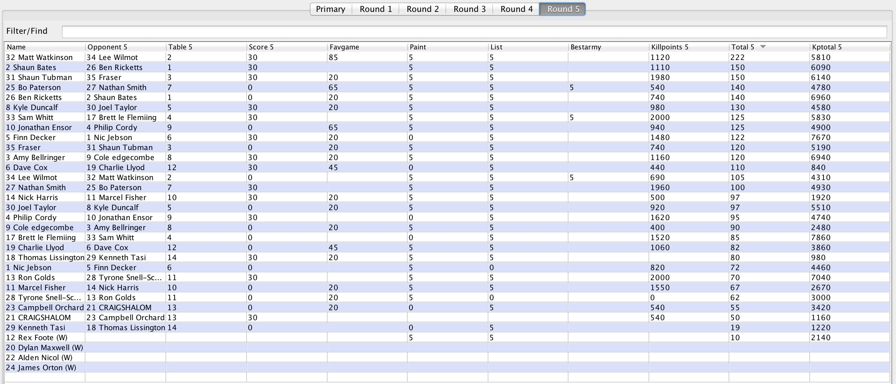

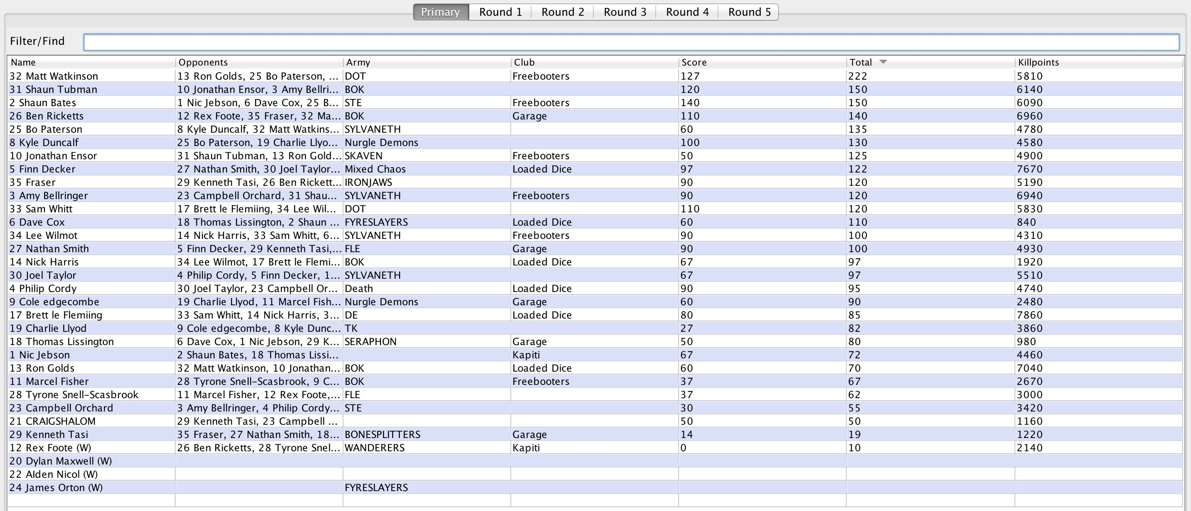

DBMM

Best Terrain  
shared by Richard Foster and Mark Pickup who started on Table 3  
  
Best Army  
awarded to John van den Hoeven with his very nice new Bastarnae force  
  
Best Opponent  
taken out in a very gentlemanly fashion by Graham Starkey, Mr Nice Guy 2017  
  
and Overall Winner and (... drum roll) the new Call to Arms Champion for 2017  
Allen Yaxley.  
  
The final scores were:1st 85 pts Allen Yaxley (Konstantinian Byzantine) ;  
2nd 79 pts Richard Foster (Early Burgundian) ;  
3rd 64 pts Andrew Brazendale (Late Imperial Roman) ;  
4th 63 pts Mark Pickup (Islamic Berber) ;  
5th 53 pts Steve Hodgson (Middle Imperial Roman) [3 games] ;  
6th 48 pts Gary Lewis (Wars of the Roses English) [2 games] ;  
7th 45 pts John van den Hoeven (Bastarnae) ;  
8th 42 pts Peter Noble (Early Sumerian) [2 games] ;  
9th 40 pts Jim Morton (Graeco-Bactrian) ;  
10th 30 pts Alastair Duncan (Early Imperial Roman; Classical Indian) .  
  
Also played with enthusiasm but less success (in alphabetical order):  
  
Nick Buckby (Patrician Roman) [3 games]  
Vince Cholewa (Marikian Byzantine) [2 ganes]  
Brent Senior-Partridge (Ming Chinese) [2 games]  
Richard Fields (Classical Indian) [2 games]  
Paul Graham (Polybian Roman) [3 games]  
Richard Mason (Saitic Egyptian) [3 games]

**Malifaux**

